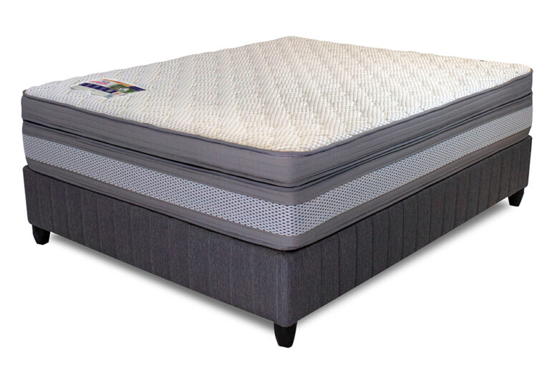


Model : Cambridge Base Set
Supplier/Manufacturer : Rest Assured
Range : Evolution Pocket Spring Collection
Prices – Bed Set :
- Single Bed Set – R12419
- Three Quarter Bed Set – R14029
- Double Bed Set – R17029
- Queen Bed Set – R18399
- King Bed Set – R22709
Prices – Mattress Only :
- Single Mattress Only – R10769
- Three Quarter Mattress Only – R12199
- Double Mattress Only – R14999
- Queen Mattress Only – R16319
- King Mattress Only – R19399
Prices - Extra Length Bed Set :
- Single Extra Length Bed Set – R13419
- Three Quarter Extra Length Bed Set – R15159
- Double Extra Length Bed Set – R18399
- Queen Extra Length Bed Set – R19869
- King Extra Length Bed Set – R24529
Prices - Extra Length Mattress Only :
- Single Extra Length Mattress Only – R11629
- Three Quarter Extra Length Mattress Only – R13179
- Double Extra Length Mattress Only – R16199
- Queen Extra Length Mattress Only – R17629
- King Extra Length Mattress Only – R20949

*Please use this link for guideline for creating the page* - https://www.bedsonline.co.za/product/rest-assured-cambridge-queen/
Rest Assured Link - https://restassured.co.za/our-ranges/evolution/cambridge/

